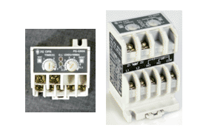 | - Used for Z CT (200MA;1.5MA)  - For the use of Normal Current CT(100A:5A,) (Special Characteristic: CT cost is low and small)  - Power Leakage Protection  - Operation Delay Time Set-up  - Wide Range of Set-up  - Wide Range of Free Voltage  - Operation Indicator and Identification  of Actual Current (LED)  - Manual (Immediate) / Electrical Recovery  - Hard Condition Resistant  - Super Economic in Power Saving
- Generator.Motor  - Lining Protection  - Power Leakage Protection for Auxiliary Equipments | - Power Leakage Protection ? Operating after {TIME} Set-up  - Power Leakage Identification  - Green LED (MONITOR) indicating Power and Operation  - Red LED (TRIP) Dimmed: indicating the State of Power Leakage  - Bright Red LED: indicating Power Leakage Operation

Items |  |  |  |  | Set-up Range
 | Rated Current | Power Leakage |  | 50 ~ 600MA
 | Time Set-up | TIME |  | 0.1sec ~ 3sec
 | Recover |  |  | Auto/Manual(Immediate)/  Electrical(Timely) Recovery
 | Operating Time Spec |  |  | Fixed Time
 | Error Tolerance | Current |  | ±15%
 | Error Tolerance | Time |  | ±15%
 | Operating Power | Voltage | AC 220V | 110V ~ 220V
 | Operating Power | Frequency |  | 50 / 60㎐
 | Contact Support | Type |  | 1-SPDT(1C)
 | Contact Support | Status |  | Normal Time Element (95 96 Close)
 | Contact Support | Rated Current |  | AC 250V / 3A Load Resistant
 | Power Saving | Resistance | between the outer  port and the circuit | Over 50㏁ for DC 500V Megger
 | Power Saving | Internal Voltage | between the outer  port and the circuit | 2.0kv normal frequency for 1 min
 | Power Saving | Internal Voltage | between contact points | 1.0kv normal frequency for 1 min
 | Power Saving | Internal Voltage | between circuits | 2.0kv normal frequency for 1 min
 | Operation Environment | Temperature | Not in Use | -30℃ ~80℃
 | Operation Environment | Temperature | When Operating | -20℃ ~65℃
 | Operation Environment | Humidity |  | 30~85% RH with no dew condensation
 | Voltage and Rated Current of Terminal |  |  | Over AC 250V 5A
 | Power Consumption |  |  | Below 0.5W
 | Outer Material
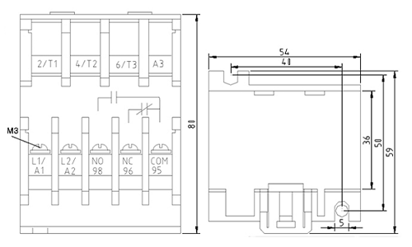
1. Check List Before Use
Please make sure that the product specifications are the same as ordered.
Check to ensure that no damage has occurred during delivery, and that there are no defects or missing items.
2. Operation Time Set-up
TIME: this refers to the time that operation of the relay is delayed by the current of power leakage that is greater than the set current. Precise set-up is required, since it works after the TIME is passed. The operating time is as marked as on the scale of the control knob.
(1) When setting up, consider the safety time of the motor and other machines.
(2) Operating Time can be set-up, and is controllable in a range of 0.1~3 seconds.
(3) Since the time is fixed, operating time will be tripped after the TIME is passed from the moment when the current from power leakage occurs, at which time the red LED will illuminate.
3. Rated Current Set-up
(1) Set the current control knob to a safe level
4. To Confirm Operating
(1) While only the power is on, if the TEST button is pressed, the power leakage indicator lamp (O.L) on the power leakage protective relay will illuminate dimly. After the set O-TIME is exceeded, the O.L will illuminate, the green power lamp will turn off and it will trip.
(2) When it trips, press the RESET button to recover the initial state. The power leakage over current indicator lamp turns off, and the power lamp illuminates.
5. Circuit Breaker Chart
